After you Log in to the SAS Studio:

To open a new editor:

Click the \*Inverted Triangle Icon and click on SAS Program as shown. A Editor will pop up to your right .

In all probability a new editor will be open when you log in automatically.

The new editor has 3 tabs : Code (where you write the SAS Code), LOG (where you see the Log of the code run ex: records processed, warnings and errors) & Results(where the output is displayed)

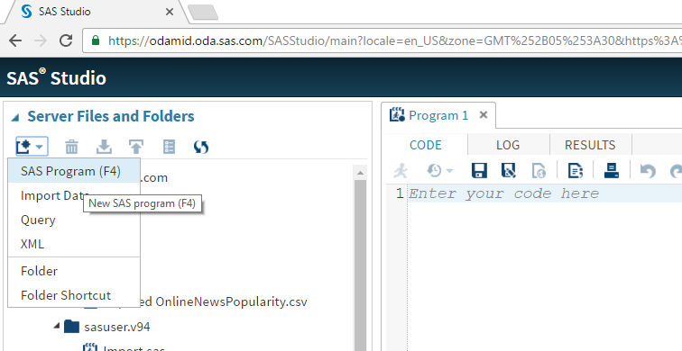

Paste the Code from the Script provided to you and run in patches as shown. Every Patch must end at the ‘run;’ command.

To run : after selecting the code snippet you may click the running man icon at the top or press F3.

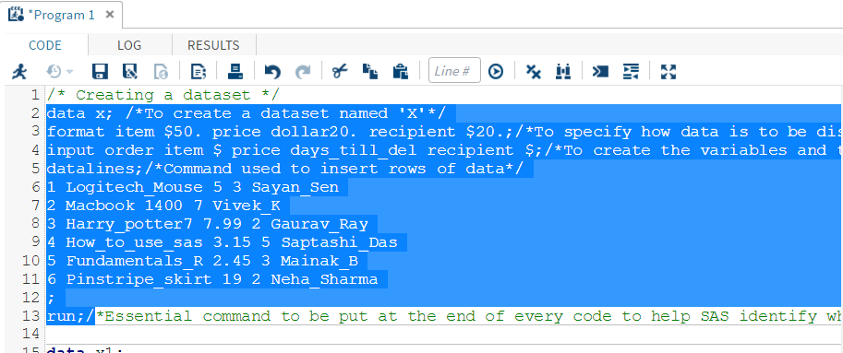

If the code runs successfully you will be automatically redirected to a New Tab called : OUTPUT DATA where you can see the data you created.

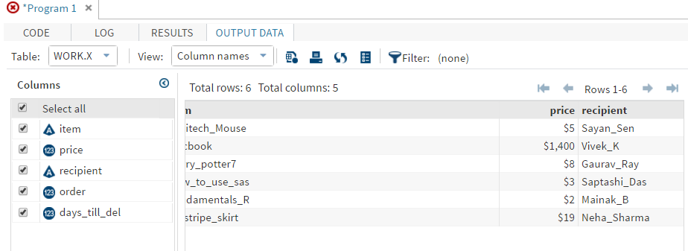

The Data you created will be by default saved to ‘work’ library as shown below:

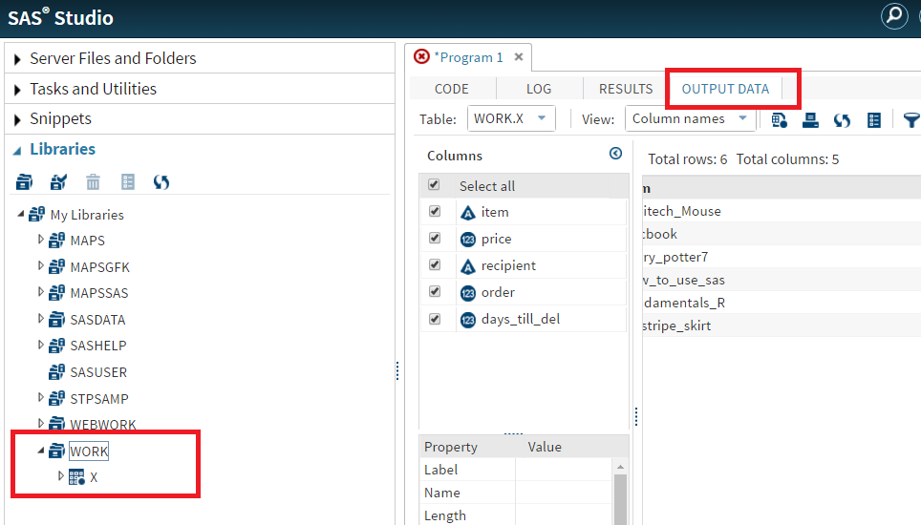

The log tab will hold the information pertaining to code you ran and if any errors encountered.

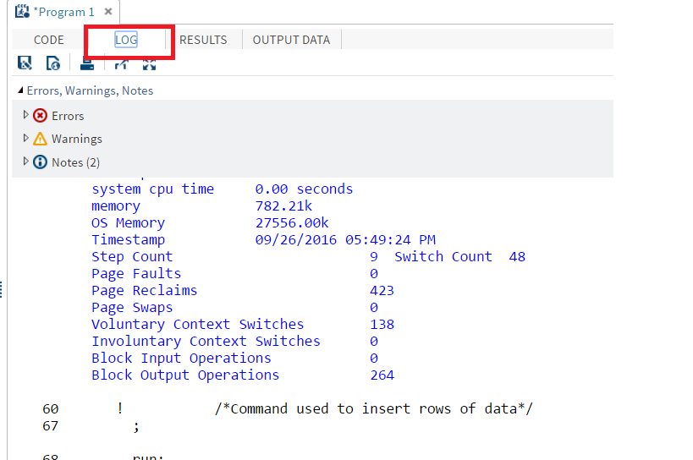

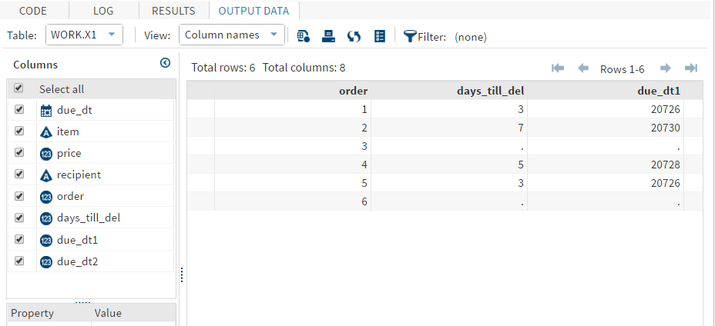

To save the script you made , press CTRL+S and as shown below select the Data folder and rename the script and click on save.

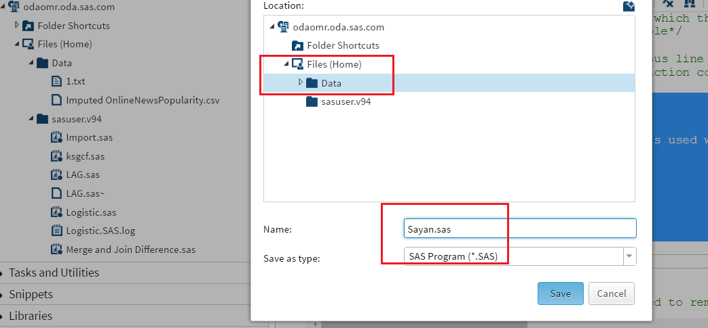

The Script shared is well commented and self-explanatory. Please explore the code by running them and try to explore the different tabs as suggested.